COMMUNITY EVENTS

REFLECTION REPORT

- Community Festival - Decision Required
- Teenage Market
- Under 18’s

- COMMUNITY FESTIVAL – 16TH MAY
This year the community festival had its biggest attendance so far. We had 47 stalls in total.
Community Stalls
- Neudrodivergent Friends In Thanet
- Thanet Lifeguard Club
- Thanet Community Safety Partnership Team
- RNLI
- POW+
- Broadstairs Library team
- RSPB
- The Gap Project
- Dad Space
- Thanet Dementia Action Alliance
- The Garden Group
- The Shed
- Broadstairs Town Council Woodland
- Friends of Pierremont
- Thanet Little Libraries
- Gap in the Market
- Thanet Wanderers Rugby Club.
- Chartwell House
- Copperfield Court - Broadstairs
- Dickens Festival
- The Pavilion Youth and Community Café
- Blackburns Funeral Directors
- Mental Health Matters
- Inspiration Creative
- St Peter’s Village Tour
- SEK
- St John’s Ambulance
- Kent Fire and Rescue

Commercial Stalls

- Wax & Whimsy
- Chloe's Fudgey Fancies
- Krysias crafts
- Bumble Cat Crafts
- Handmade by ausra
- I made it my own
- The Sinful Slice
- ME-TIME
- Turquoise Gem Home
- Pitcher's Preserves
- R and R Dog Treats
- Rufnek London
- Tania Ice Cream
- Candy Land
- Swing Grill
- Prime Event Catering
- Chelsea Jones Jacket Potato Van
- Bouncy Castle
- Emerald Face Painting

Spend Report

Budget | £ 3,000.00
 | Exc VAT | VAT | Inc VAT
Income
Stalls | £ 528.00 | £ 132.00 | £ 660.00
Outgoings
First Aid | -£ 203.00 | -£ 40.60 | -£ 243.60
Face Printer | -£ 250.00 |  | -£ 250.00
Ice Cream | -£ 292.00 |  | -£ 292.00
Bouncy Castle | -£ 275.00 |  | -£ 275.00
STAGE | -£ 704.20 | -£ 140.84 | -£ 845.04
Music | -£ 920.00 |  | -£ 920.00
Thanet Event Admin Fee | -£ 21.00 |  | -£ 21.00
 | -£ 2,665.20 | -£ 181.44 | -£ 2,846.64

This year we were in budget due to not paying out for stalls which worked out very well.
Decision Required
Does the council want to host this event for a fourth year?
What date would the council like to hold for the event?
Based on the budget, does the council thing the budget would work for a third year?

- TEENAGE MARKET
Update – After offering Pierremont Hall, Teenage Market decided to go with Pavillon, during Dicken’s Festival.

- UNDER 18’S

EASTER FILM AFTERNOON 3RD April
Name of Event: Under 18s Easter Film Afternoon
Date of Event: 3rd April 2026
Event Overview: The event was a simple, feel-good activity for families to come to, it included the children being able to fill their own snack cups full of easter themed treats then a showing of Winnie the Pooh: Springtime with Roo.
Summary of Expenses:
EXPENSE ITEMS | COSTS
Film License | £90
Snacks | £26
TOTAL | £116

Number of Attendees: 68
We had 70 on the guestlist, only 2 people didn’t show. We were still getting enquires until the morning of that I couldn’t accommodate due to capacity of the venue.
Feedback: We had many thank you from the parents as they were leaving, the only feedback from the event from myself is sometimes the projector wasn’t loud enough to get over the noise of the attendees even though it was at max volume so sometimes you couldn’t hear the film and we also had a group leave about 20 minutes into the film starting, they didn’t give a reason just wanted to leave.
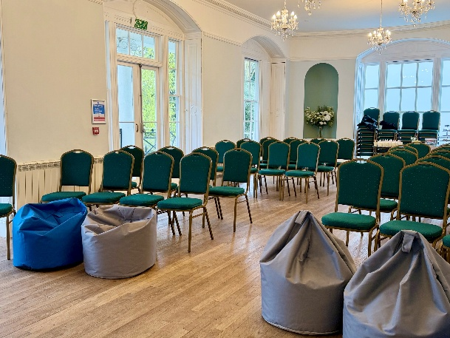
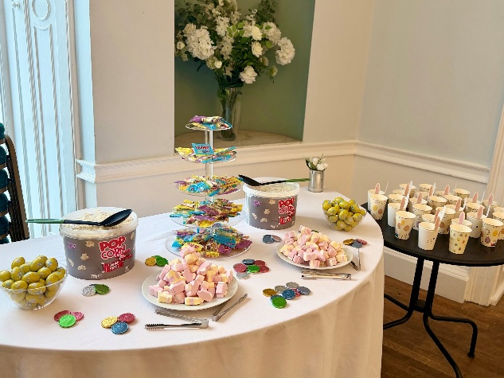
Photos:

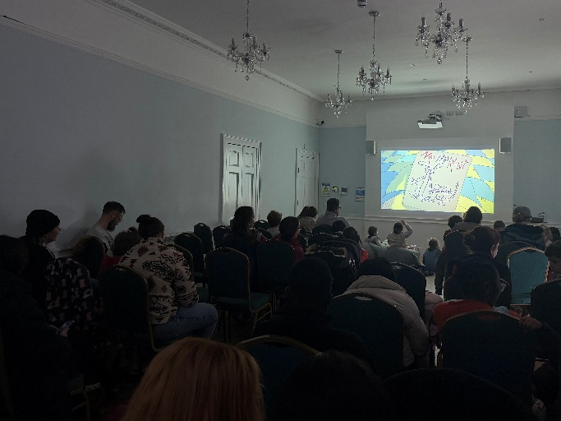
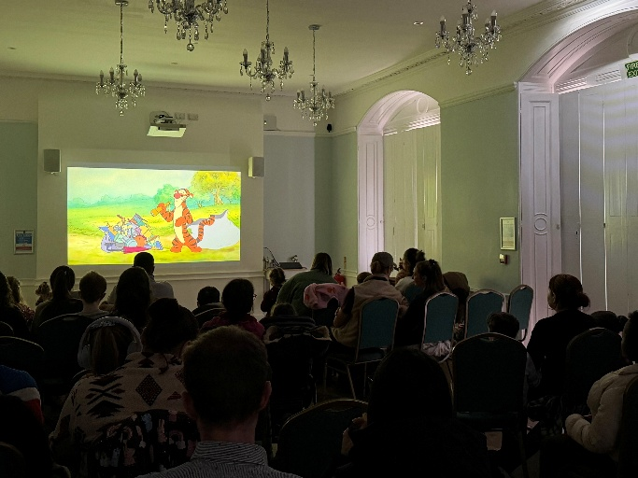

DEFIBRILLATOR WORKSHOP - 9TH APRIL
Name of Event: Under 18s Defib Workshop
Date of Event: 9th April 2026
Event Overview: The event was an educational workshop teaching the attendees basic lifesaving skills and how to correctly and safety use defibrillators.
Summary of Expenses: Hopkins + hosted the workshop for free so no expense for this event.
Number of Attendees: 8
We had 9 on the guestlist, only 1 people didn’t show.
Feedback: 3 of those that attended were in the Mayor of Broadstairs Awards, when signing it asked for feedback and they said they enjoyed it and was a good skill for them to learn. Another two were keen to receive their certificates from Hopkins + as it is a good addition they can add to their CV.
My personal feedback is I don’t think he engaged that well with the youth and if we was to host this type of workshop again, I may look for an alternative route, however I think he would be great for an adult workshop.
Photos:
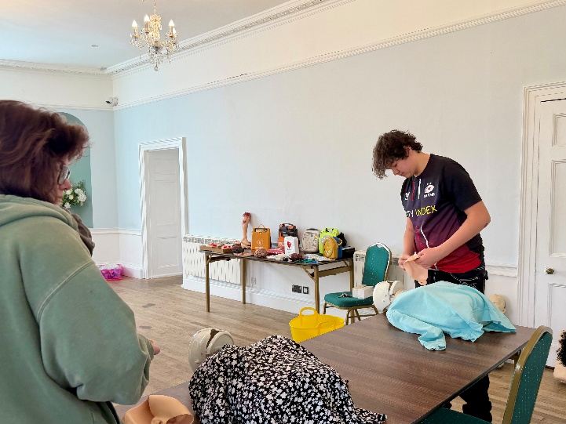
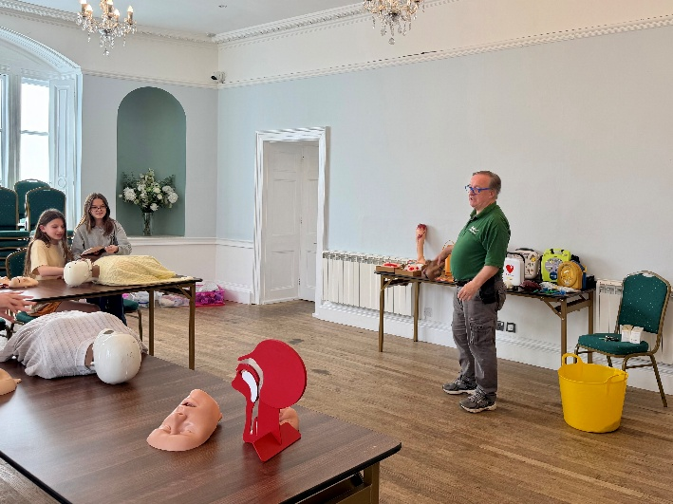

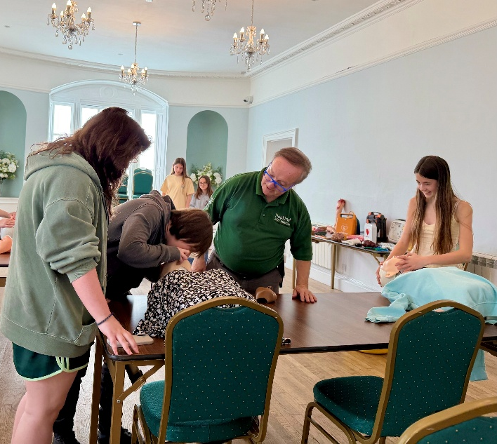
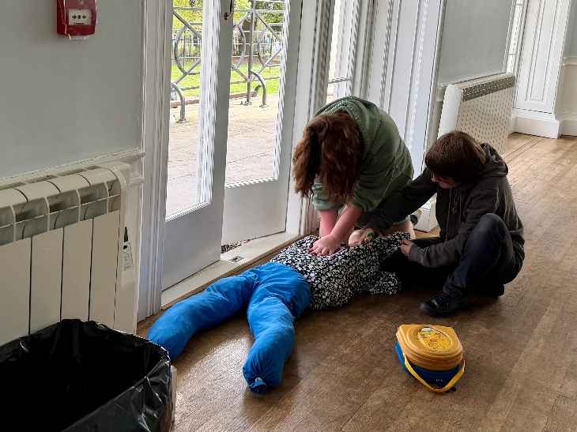

FORECAST REPORT

- Bandstand - Decision Required
- A Midsummer Night’s Dream at the bandstand - Decision Required
- Summer Theatre
- Punch and Judy
- Heritage Week
- Christmas Market - Decision Required
- Under 18’s
- Fireworks - Decision Required
- Wellbeing Event
- Other - Decision Required

- BANDSTAND – EVENTS MANAGER
Decision Required

Parking Permits – should we be issuing out parking permits to bands?
Dates for 2027 – 26th March – 10th October
No dates during;
- Spring Food Festival
- Dicken’s Weekend
- Folk Week
- Bank holiday weekend – with the fairs on Victoria Gardens
- Autumn Food Festival
Increasing the payment window from 14 days to 30.

- A Midsummer Night’s Dream at the bandstand
East London Shakespeare Festival (ELSF) will be touring Thanet with a new production of A Midsummer Night’s Dream and this will be performed at the bandstand in Broadstairs on the 31st July at 18:30 for FREE.
They will be performing at Quex Park and Ellington Park in Ramsgate and tickets are from £7.50 – 15.00 per person.
Costs – Miscellaneous Events Budget
Actors/Stage Manager Fees:
Day rate: £100 * 6 actors + 1 Stage Manager/actor £700.00
Travel and overheads costs for the day £150.00
Total: £850.00
They have also had the following room hire for FREE from us totalling 25 hours.
- 23rd June 16:30 – 21:00
- 30th June 16:30 – 21:00
- 22nd July 12:00 – 21:00
- 31st July 11:00 – 18:00
At the commercial rate this would have been at a cost of £1500.00.
Decision Required
In addition to the Summer Theatre, would the committee like to propose for next year we offer theatre at the bandstand?

Would the committee like this to go to main council for consideration for budget approval for 2027-28?

- SUMMER THEATRE – NO UPDATE
Performance Details
Audience Show | Date | Times | Cost
- Caspian's Storm | 28/07/2026 | 1pm, 3pm | 702.00
- Victor and Albert | 30/07/2026 | 7pm | 624.00
- Tractor Time | 05/08/2026 | 1pm, 2pm, 3pm | 702.00
- Tales for an Unruly Audience | 06/08/2026 | 7pm | 538.20
- The Butterfly House | 19/08/2026 | 1pm, 2pm, 3pm | 585.00
- Three Idle Women | 20/08/2026 | 7pm | 624.00
- Uglybugs Wingding | 26/08/2026 | 1pm, 2pm, 3pm | 620.10
- Grandma's Shop | 27/08/2026 | 7pm | 507.00
Total: |  |  | 4902.30

Press Release can be found here:
TRASH TO TREASURES CRAFT WORKSHOP
The Environment indicatives will be a key part of Summer Theatre this year.

- PUNCH AND JUDY – NO UPDATE
11:00, 12:00 and 13:00. Duration of each show approx. 30 minutes. 36 shows over 12 dates in July and August 2026.
Dates agreed:

Wednesday 29th July
Saturday 1st August
Sunday 2nd August
Friday 14th August
Saturday 15th August
Sunday 16th August
Friday 21st August
Saturday 22nd August
Sunday 23rd August
Friday 28th August
Saturday 29th August
Sunday 30th August

Press Release can be found here:

- HERITAGE WEEK – 11TH September – 17th September
The theme this year is jobs. Historic photos, documents and leaflets will be display.
11th – 17th September 09:00 – 13:00
Film Afternoon– The Night of the Museum
Tour Times - 10:00 and 12:00
Tour - Start at the front of the main entrance and walk through to the lobby. Then through to the Chamber Hall. Outside to the gardens. Then round to the Music Room and back to the main entrance.
Last year 87 visitors came over the week.
Press Release can be found here:
- CHRISTMAS MARKET – 28TH NOVEMBER
To consider Stall options provided by the events and bookings manager
Attachment 5

Decision Required
What option would the committee like?

- UNDER 18’S
NEWS: From Spring 2027, under-16s will no longer be able to use certain social media. Children will still be able to go online safely, for learning, news, games and staying in touch with friends and family.
BATTLE OF THE BANDS – 3RD AUGUST
From 12pm to 6pm at the bandstand.

Press Release can be found here:
4/5 sets booked
- Matilda May
- Kingfisher
- The Climbing Trees
- Musical Chairs Club
We have last years winners attending.
Cost breakdown
Sunshine Ocean Records | £ 350.00
Recording Studio | £ 250.00
Half a years rehearsal space at Pierremont Hall | £ 264.00
Booking on the 2027 Bandstand Guide | £ 150.00
 | £ 1,014.00

DEFENCE WORKSHOP – 10TH OCTOBER
Looking to host a deference workshop at Pierremont Hall for the community.
Date: Saturday 10th October - World Mental Health Day 2026

We will be working with The Kent Self Defence Workshop to host 2 groups targeted towards Young Men and Young Women.
Tickets will be at cost. Defence workshop, welcome drink and treat TBC.
Tickets: | £5.00
2 x 30 attendees: | 60
Estimated income: | £300.00
The Kent Self Defence Workshop fee: | £500.00
Suppliers Budget: | £100.00
Spend: | £300.00

HALLOWEEN BOO BASH & THRILLER FILM NIGHT
Boo Bash | Costs
Exclusive Sounds | £390
Fruit | £20
 | £410
Halloween Film Night | Costs
Film Licence | £90
Snacks | £20
Halloween Cups | £10
 | £120
Overall Costs = £530

CHRISTMAS MOVIE NIGHT
Another film night at Christmas for under 18’s to enjoy.
Cost = £90 film licence and £10-20 on snacks = £110.00

- FIREWORK NIGHT – 5TH NOVEMBER
5th November fireworks have been booked, and events plan has been submitted to TDC for an events permit.
The SuperMicks (with Gianni Scalera and The Jury) have been booked from 6:00pm – 7:00pm & 7:15pm-8:00pm.

Fireworks at 7pm – 7:15pm
 | Cost ex VAT | VAT | TOTAL | Company | PO No.
Fireworks | £ 4,000.00 | £ 800.00 | £ 4,800.00 | Viking Fireworks
Security |  | £ - | £ - | Quotes Sent
Waste |  | £ - | £ - | Quotes Sent
First Aid |  | £ - | £ - | Quotes Sent
Toilets | £ 480.00 | £ 96.00 | £ 576.00 | True Loo | 2018
Music | £ 350.00 | £ - | £ 350.00 | The SuperMicks | 2022
TDC Land |  | £ - | £ - | Thanet District Council
TDC Road Closure |  | £ - | £ - | Thanet District Council
TDC Admin Fee |  | £ - | £ - | Thanet District Council
Marketing |  | £ - | £ - | Lanes - Flyers and Posters
 | £ 4,830.00 | £ 896.00 | £ 5,726.00
Left Over | -£ 4,830.00

Decision Required

Committee’s approval on NEW RISK ASSESSMENT Attachment 6

Committee’s approval on TRAFFIC MANAGEMENT PLAN Attachment 7

- WELLBEING EVENT - LAUGHING YOGA SESSION – 2ND OCTOBER – NO UPDATE
This is a Laughing Yoga Session followed by a Mingle hour, the idea is to bring those in the community together to help fight those summer blues as we enter the winter months.
- OTHER IDEAS
New Event - RPM Bike Trials Display Show
The council has been approached with a proposed offering of an RPM Bike Trials Display Show in Broadstairs.
Details of both our attractions below. Fees are subject to change in 2027.

For the RPM bike show we would need a space of 10 x 10 m with barriers around it provided by you guys, and then I can do the rest. The standard fee for this would be £1700 all-inclusive per day so no VAT to add on and no travel expenses.

You can see the bike show in action here: https://www.youtube.com/watch?v=auBJ9nLaa0A

For The Slackline School we would need a space of approximately 12 x 7 m. The standard fee for that would be £1300 all inclusive per day.

You can see The Slackline School in action here: https://www.youtube.com/watch?v=r5-P6_D3u4c

Both of these attractions are covered by public liability insurance up to £10 million. We also provide a site specific risk assessment for each activity for each event.

https://www.youtube.com/watch?v=uWyZUcBY8i4

https://www.youtube.com/watch?v=r5-P6_D3u4c&t=45s

Rich Pearson - Owner & Operator: RPM Bike Trials Display Show

Decision Required

Is this something that the committee would like to offer the community for Under 18’s, bandstand entertainment or Community Festival?

Would the committee like this to go to main council for consideration for budget approval for 2027-28?

