BOOKINGS
We currently have 26 weddings (civil ceremonies, receptions, blessings, full day weddings) and 43 events total for commercial bookings.
MISSED OPPORTUNITIES
We’ve had several enquires this month alone, for birthday parties (mainly 1st birthday parties), christenings and engagement parties, that haven’t booked due to the cost being too high. To get around this we have come up with an idea that we remove the advertising of £100.00 per hour and instead start promoting that we only offer packages on weekends.
Decision Required
Do the committee members agree to this change of marketing technique?
REGULAR BOOKERS
A few previous regular bookers terminated their bookings in April however we have also gained new ones that are due to start in September.
- Monday, Thursday and Friday MR – Dance Group (Term Times) – Due to start in September
- Tuesday MR – Elsies Tiny Tot Adventure (Term times) – Due to start in September
- Wednesday Mornings MR – Yoga (Weekly)
- Wednesdays Nights MR – Yoga (Weekly)
- Sunday MR – Yoga (Weekly)
KENT WEDDING AWARDS
As requested, we have applied for the Kent Wedding Awards for the 3rd year, we have decided to apply for two categories.
- Category 1: Wedding Venue of the Year/ Something Different
- Category 2: Wedding Events Team of the Year
We should find out if we made it into the finals in November/December time.
Costs to apply | Cost PER
Application fee x 2 categories | £65.00 | £130.00
To attend the award night x 2 tickets | £90.00 | £180.00
Travel Expenses | £15.00 | £30.00
 |  | £340.00

HITCHED WEDDING AWARDS 2026
Pierremont Hall has been awarded the Hitched Wedding Awards 2026. This award is given to venues based on the reviews that couples have written about us and recommended us to others.
In result of this the events department will be creating a marketing plan around showcasing all our testimonies from the past 5 years. This will be a digital portfolio on our website and social media.

COMMERCIAL REFLECTION REPORT
- Mother’s Day
- Hanging Baskets Workshop
- Dicken’s Festival Cream Tea
- Dicken’s Festival Antiques and Collectibles Fair

- MOTHER’S DAY - 15TH MARCH
Aim – To provide a collaborative event with an environmental initiative with the Community Engagement Officer by hosting a herb planting experience where guests can plant and design their own recyclable planter. Alongside a ‘How to make’ Botanical mocktail/cocktail, creating an engaging experience for guests.
Sale price - Three tins and three herbs: £20.00 per person
 | Estimated | Actual
Ticket Sales | 48 | 13
Income Generated | £960.00 | £260.00
Profit Generated | £480.00 | £97.65

Outcome – Although not as many tickets were sold as expected, the event was still a success as it managed to make a profit and those that attended enjoyed themselves.
Feedback – The ticket price was too high.
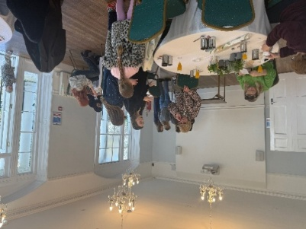
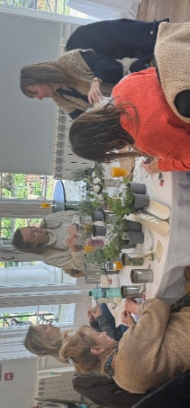
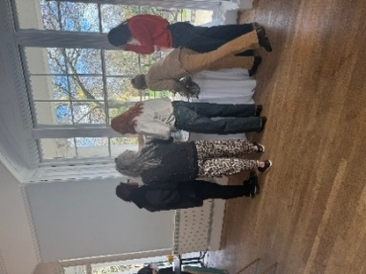
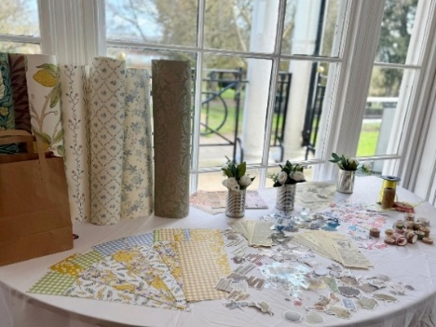
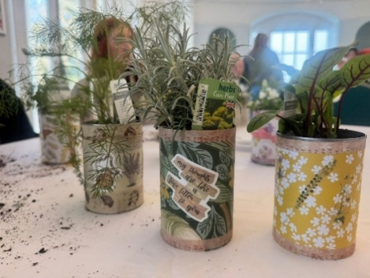
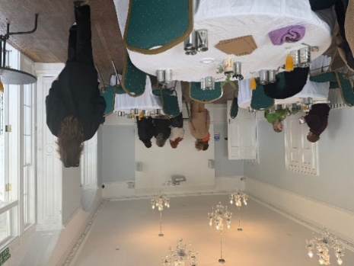
Photos
- HANGING BASKET WORKSHOP – 17TH MAY
Aim – To use the remaining hanging baskets from the previous year, the Community Engagement Officer hosted the event alongside the Event Supervisor who put together a little list of mocktails/cocktails which were bought at an additional cost. There will be 40 baskets available.
Sale price – Hanging Baskets: £15.00 per person, Mocktails: £3.00 each, Cocktails £5.00 each.
Budget was managed by Community Engagement Officer
Tickets sold 12 (one purchase from a walk in)
 | Actual inc VAT
Income Generated (Baskets inc Walk In) | £285.00
Income Generated (Mocktails) | £6.00
Income Generated (Cocktails) | £20.00
Income Generated (Bar Sales, Drinks) | £48.00
Total Income Generated: | £359.00

Outcome – Although not as many tickets were sold as last year, the event was still a success, and we had a lot of interaction with the events notice board as this was displayed with flyers throughout the day.
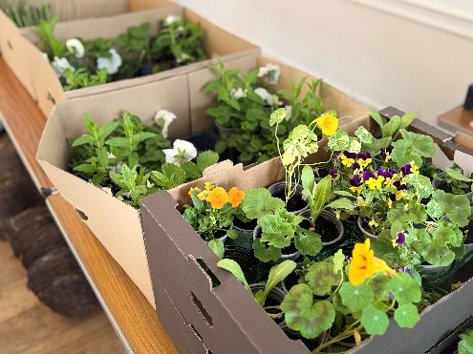
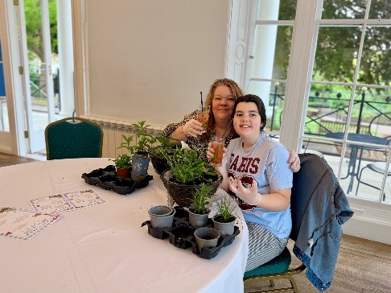
Photos
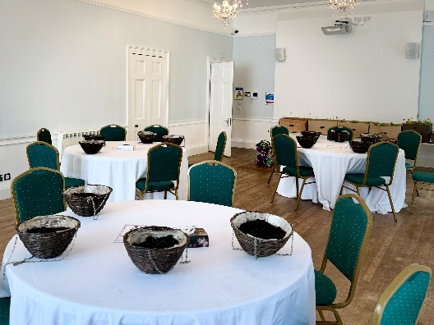
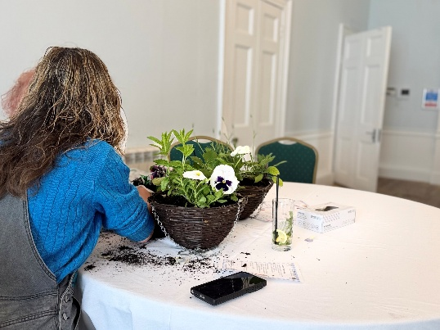
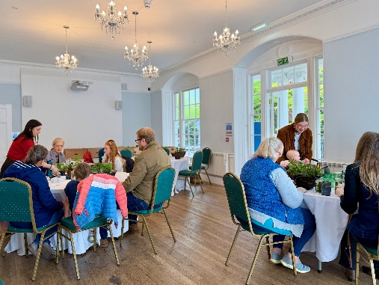
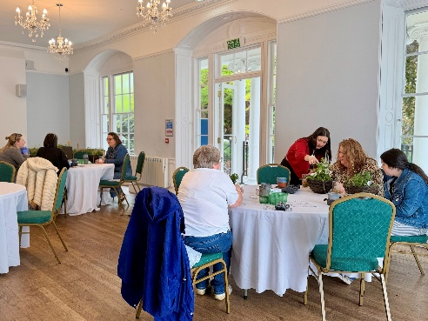

- DICKENS FESTIVAL
CREAM TEA & PARADE – 13TH JUNE
Aim –– To host something at Pierremont Hall, alongside the Dickens Festival to provide more entertainment in the town. Running before the parade which is due to leave at 12pm from Pierremont Hall.
Sale price – £5 per cream tea.
Tickets sold – 24
Walk Ins - 2
Items | Total
Income Generated | £120.00
Bar Sales, Drinks Income Generated | £38.50
Total Income: | £158.50

Outcome – People loved the cream tea and the staff dressed up. We worked with The New Old Bakehouse with the catering and Bleak House lent us the costumes.
Feedback – We had a lot of people walk in for cream teas and we sold out. Next time we could justify ordering around 50 scones and booking from 10am – 12pm.
Photos
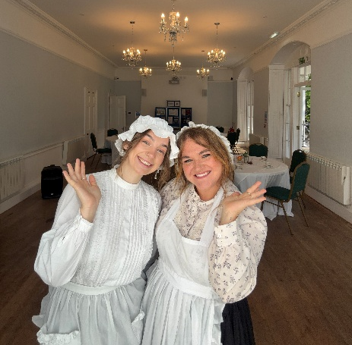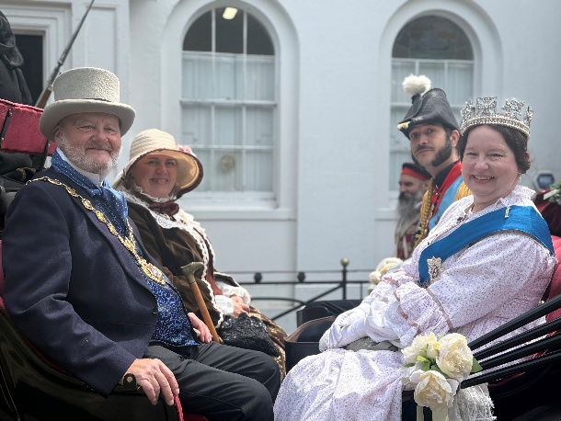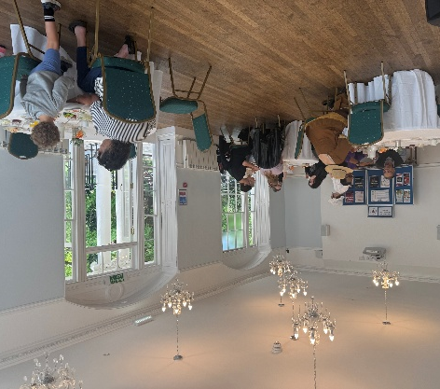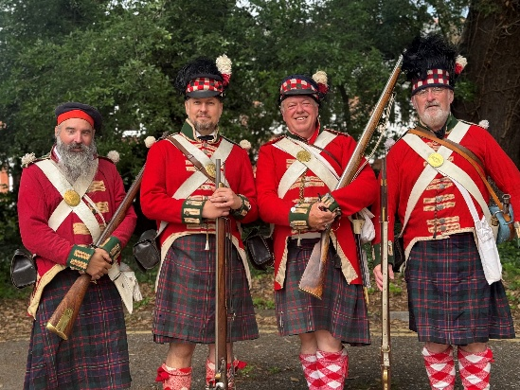

ANTIQUES AND COLLECTIBLES FAIR – 14TH JUNE
Aim – To host something at Pierremont Hall, alongside the Dickens Festival to provide more entertainment in the town.
Sale price – Started at £40 each for a pitch outside however due to no sales we lowered the outside pitch to £20 per person and decided to run an inside pitch specifically for vintage clothing and accessories for £10 each.
Tickets sold (Outside) – 9
Tickets sold (Inside) – 5
Items | Total
Income Generated (Outside) | £180.00
Income Generated (Inside) | £50.00
Bar Sales, Drinks | £17.00
Total Income: | £247.00

Outcome – The event supported the load of events within Broadstairs for the weekend of Dicken’s Festival. It was a great day with stallholders happy with the amount they sold.
Feedback – use the inside as more cream teas and just book people for outside next time.
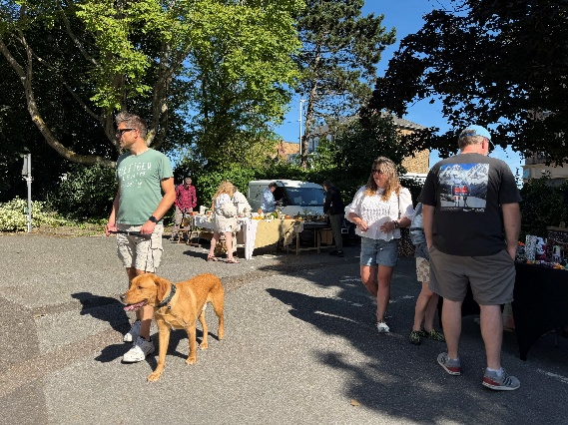
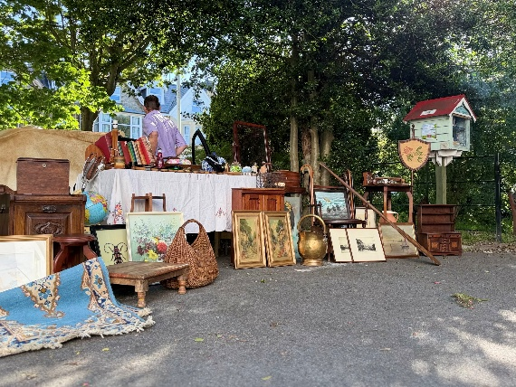
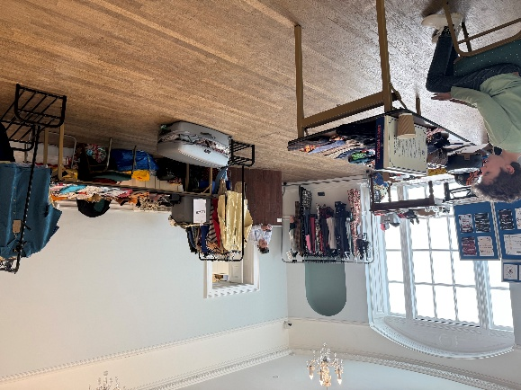
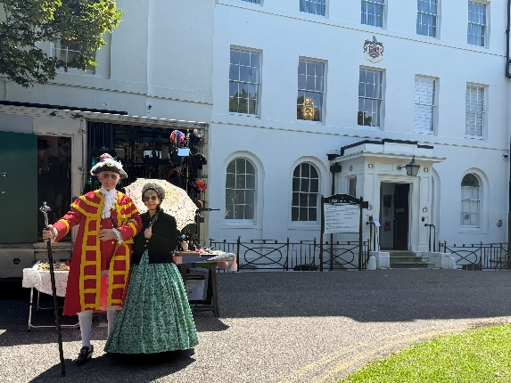
Photos

Next year the event will be over Father’s Day from the 18th – 20th June.
We have agreed that the festival can use Pierremont Hall for the start of the parade. We have informed them that a Community Free Hire Agreement will be needed and that we’d require a copy of their risk assessment and Events Management Plan as they are on our site.

Decision Required
Proposed Dicken’s Festival 90th IDEAS

Pierremont Hall is thrilled to announce its official event lineup for the historic 90th anniversary of the Broadstairs Dickens Festival, running from Friday 11th June to Sunday 13th June 2027. Experience the charm of Victorian England right in the heart of Broadstairs with immersive activities, traditional treats, and vibrant community celebrations.

FRIDAY
- The Grand Dickens Ball (Friday Evening): Kick off the weekend at our flagship formal gala. Sip a welcome drink of traditional Victorian Punch beneath spectacular period decorations. Enjoy live music from a classical string quartet, dramatic theatrical readings, fun Dickenson games, and a continuous service of gourmet canapés and savoury platters. £30-50 per person (costs on next page)
SATURDAY

- Traditional Dickensian Cream Tea (Saturday 10AM – 12PM): Indulge in a classic British tradition with fresh scones, jam, and clotted cream served in our elegant setting.
- The Grand Parade (Saturday, 12:00 PM): Watch the festival's flagship spectacle launch from the grounds of Pierremont Hall. Marvel at the sea of stunning Victorian costumes as the procession winds its way through the High Street.
FROM 2PM TWLIGHT WEDDING BOOKED
SUNDAY
- Antiques & Collectibles Fair & Traditional Dickensian Cream Tea (Sunday, 9:00 AM – 3:00 PM): Hunt for vintage treasures, second-hand clothing, and rare trinkets at our popular indoor and outdoor market stalls.

Decision Required
Would councillors like us to grow on these ideas?
Is there anything else that the committee would like us to explore.

Friday Dickensian Ball cost

Target number 30 |  |  |  | Maximum number 50
Dickensian Ball At Cost | pp | 30 |  | Dickensian Ball At Cost | pp | 50
Canapes Savory Platters | £ 4.00 | £ 120.00 |  | Canapes Savory Platters | £ 4.00 | £ 200.00
Welcome Drink of Victorian Punch | £ 4.00 | £ 120.00 |  | Welcome Drink of Victorian Punch | £ 4.00 | £ 200.00
String Quartet | £10.00 | £ 300.00 |  | String Quartet | £ 6.00 | £ 300.00
Decorations | £ 3.33 | £ 100.00 |  | Decorations | £ 2.00 | £ 100.00
Theatrical Readings |  |  |  | Theatrical Readings
 | £21.33 | £ 640.00 |  |  | £ 16.00 | £ 800.00
Dickensian Ball at sale cost | pp | 30 |  | Dickensian Ball at sale cost | pp | 50
Canapes Savory Platters | £10.00 | £ 300.00 |  | Canapes Savory Platters | £ 10.00 | £ 500.00
Welcome Drink of Victorian Punch | £ 7.00 | £ 210.00 |  | Welcome Drink of Victorian Punch | £ 7.00 | £ 350.00
String Quartet | £10.00 | £ 300.00 |  | String Quartet | £ 6.00 | £ 300.00
Decorations | £ 3.33 | £ 100.00 |  | Decorations | £ 2.00 | £ 100.00
Theatrical Readings |  |  |  | Theatrical Readings
 | £30.00 | £ 900.00 |  |  | £ 30.00 | £ 1,500.00
 | pp | 30 |  |  | pp | 50
Estimated Bar Takings | £ 5.00 | £ 300.00 |  | Estimated Bar Takings | £ 5.00 | £ 500.00
Total at sales cost |  | £ 1,200.00 |  | Total at sales cost |  | £ 2,000.00
Estimated income |  | £ 560.00 |  | Estimated income |  | £ 1,200.00

COMMERCIAL FORECAST REPORT
- Paint and Sip – Recycled event
- Open Day – Marketing Event
- Move & Mingle – Wellbeing Event

- PAINT AND SIP – 19TH SEPTEMBER
Aim – Recycle unused stock
From 2020 we purchased long steamed crystal wine glasses (60) which turned out to be very unpredictable for the environment due to the dishwasher not being commercial and the glasses being too fragile. Meaning if used they’d have to be washed by hand.
That weekend is Pride in Broadstairs so we will look to be open on the 19th September and sell £10.00 tickets for the experience.
Items | Total
Estimated Income Generated | £600.00
Cost of materials estimated £300.00  £3.00 per glass x 60 = £180.00  £9.82 paint pens x 3 = £29.46  1 glass of wine per person (60) = 12 bottles = £82.20 | -£300.00
Bar Sales, Drinks extras estimated | £200.00
Total Income: | £500.00

- OPEN DAY – 27TH SEPTEMBER
Aim - Marking Event
To have the building open and styled to show to potential new commercial bookings for 2027/2028, both the Events Manager and Supervisor will be onsite to answer any questions and get people booked in.
This is ready to be marketed from July onwards. Open to the public from 11am-2pm.
- MOVE & MINGLE – 2ND OCTOBER
Aim – to host a wellbeing event
Working with a third-party yoga instructor to bring some fun to the winter month. This is a Laughing Yoga Session followed by a Mingle hour, the idea is to bring those in the community together to help fight those summer blues as we enter the winter months.
The event will be on Friday 2nd October 2026 which is National Smile Day (that can be used for marketing). Syliva Tillman will be hosting the event. We will sell the tickets at £5 per person which will cover the costs of the host plus the tea and coffees after.
Items | Total
Yoga instructor: | £75.00
Estimated Tea and Coffee per person: | £0.50p
Tickets per person: | £6.00
Maximum 30 people in the Chamber Hall – Estimated income: | £180.00
Estimated profit: | £90.00

