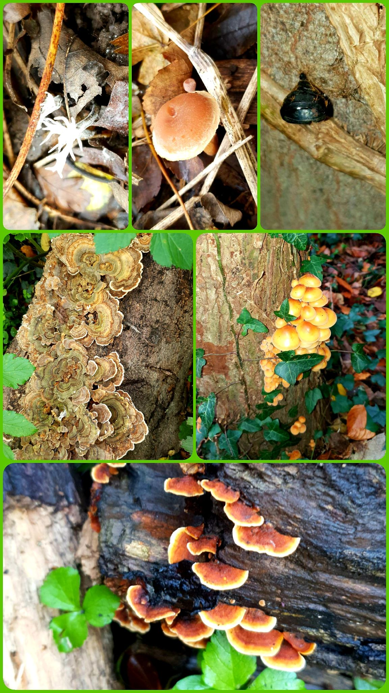

Mockett’s Wood Update 31-12-2025

It has been a busy few weeks in the run up to Christmas & New Year. Repairs & improvements to existing dead hedging have continued and we’ve also been installing new fencing & hedging to protect areas of the wood we want to regrow, recover & re-wild.

Paul, our Facilities Officer and Martin, one of our keen volunteers, have been providing a lot of assistance with fence construction. Volunteers Simon & Andy have also been a great help.

All our regular volunteers are an essential part of the woodland team & their help this year has been extremely valuable.

The paths & areas we have previously closed off are already starting to improve & biodiversity seems to be increasing. This is particularly noticeable in the diversity of fungi starting to appear in the woodland. Recent wet weather has helped.

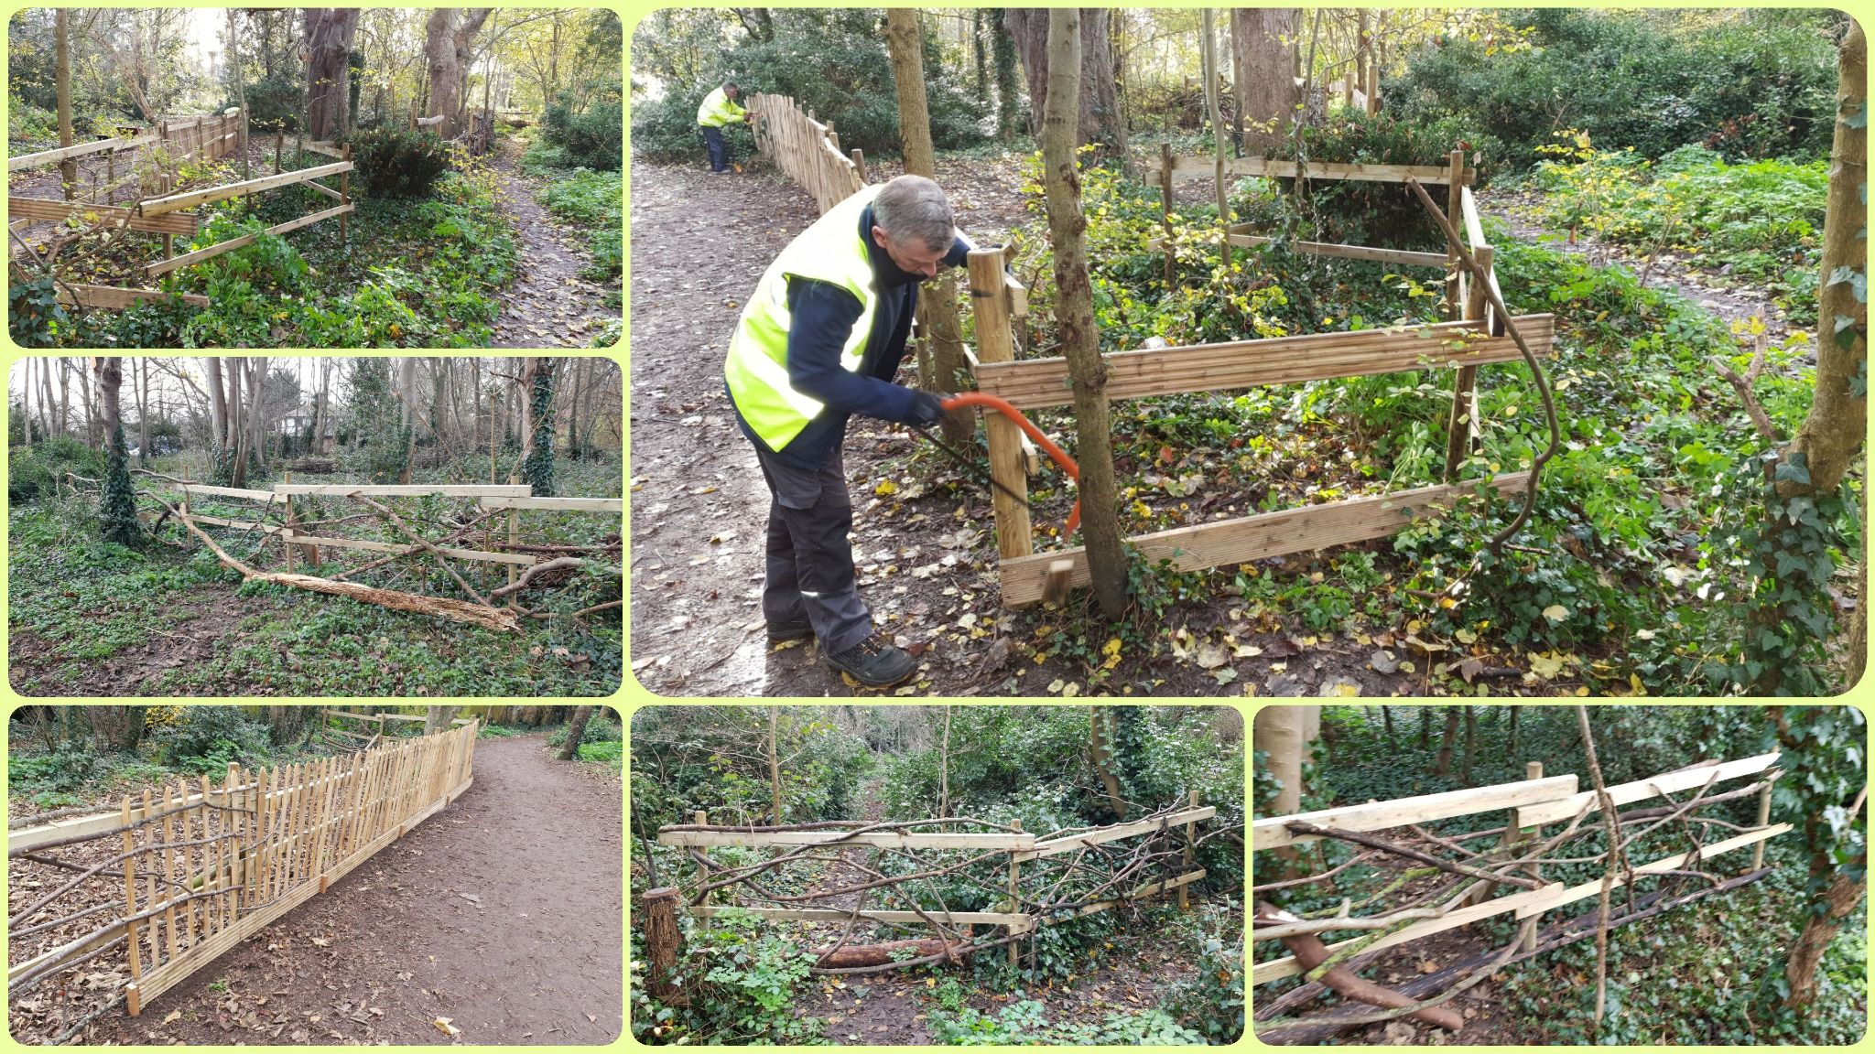
It is always satisfying to find new species in Mockett’s Wood & we will continue to monitor & report on the diversity of fauna & flora going forward into 2026.

