
MOCKETT’S WOOD PLAN

MOCKETTS WOOD IS BEING DEVELOPED & IMPROVED OVER A 5 YEAR PERIOD ACCORDING TO A MANAGEMENT PLAN COMMISSIONED IN 2024. THE AIMS OF THE PLAN ARE:
- MANAGE EXISTING WOODLAND HABITATS & ENHANCE BIODIVERSITY
- ENSURE THE WOODS ARE WELCOMING, SAFE & ACCESSIBLE.
Cleaner. Safer. Kinder
- MAINTAIN & IMPROVE THE WOODLAND CONDITION.
TO ACHIEVE THESE AIMS CERTAIN AREAS & PATHS ARE BEING CLOSED OFF TO ALLOW THEM TO REGROW, RECOVER & RE-WILD. A SERIES OF NEW PATHS & CAMPS ARE ALSO BEING CREATED.
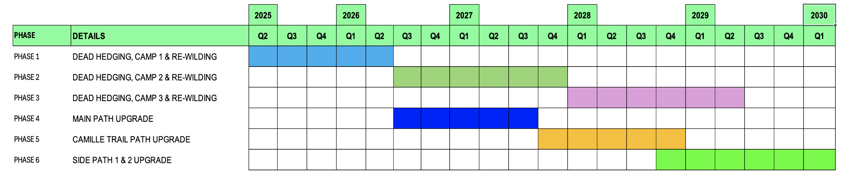
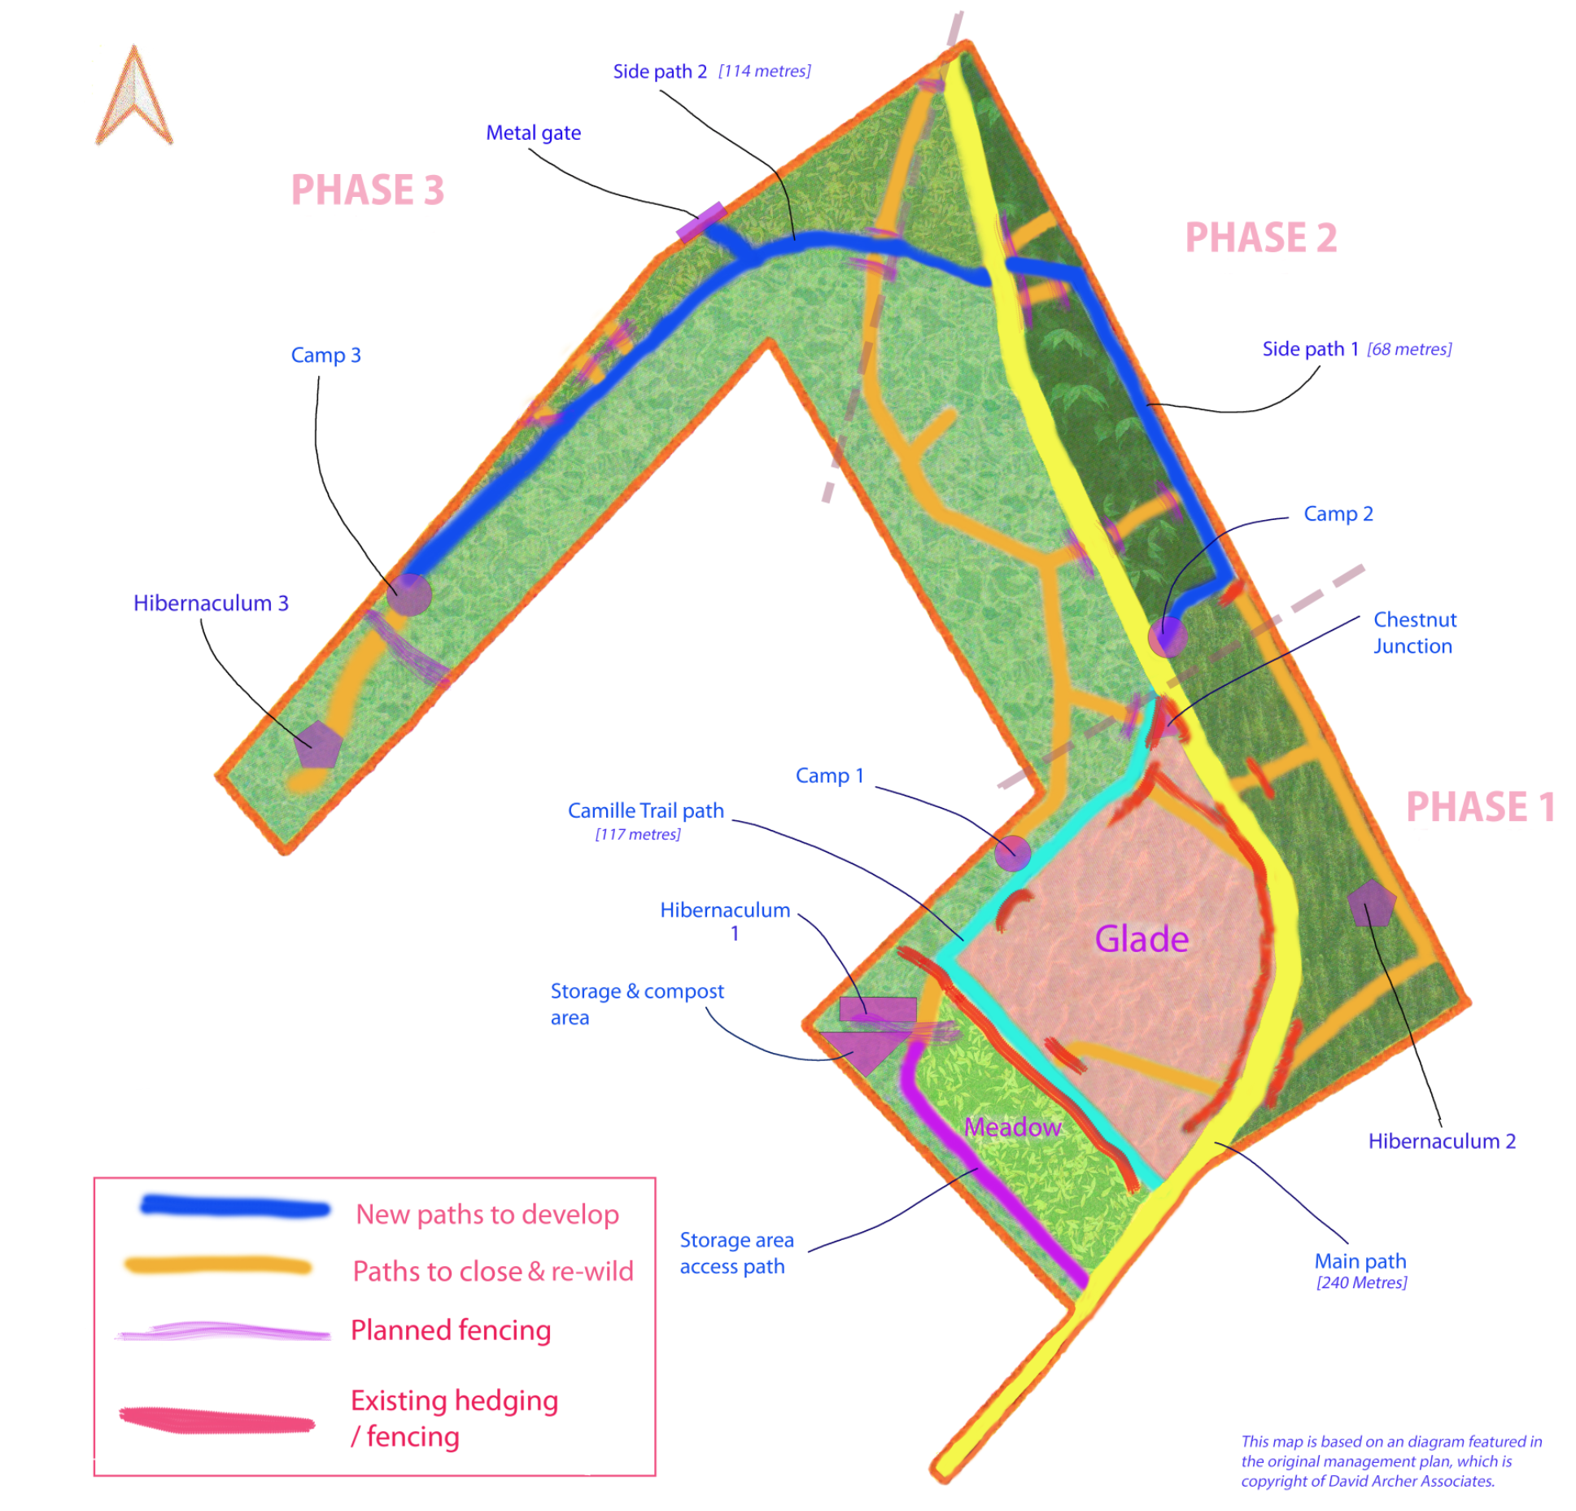
woodlandofficer@broadstairs.gov.uk
Ver 3-9 / 31-12-25

