UNDER 18S
Working with Charles Dickens School
We have had two meetings now with the children with homework being set each time, currently waiting for the Charles Dickens Teacher to give us an update on where the students are at so we can get another meeting put in place.
We may postpone the party to a valentine’s events due to the short amount of time left till Christmas which the Charles Dickens teacher also agreed (dependent on where the children are at in their planning)
Teenage Market – 20th September
The Teenage Market had great success even consider the hurdle (the weather) we had to deal with the morning of, we hosted 31 stalls, and a cake stand inside with a steady flow of the public throughout the whole day.
We had great feedback in person and online when social media posts were made.
The Event Supervisor also spoke to TDC about hosting another in 2026, they mentioned it is down to budget and will be in contact.
Bar profits made: £210.60

October – Halloween Kids Party and 13 – 17s
Boo Bash got fully booked with 68 children on the list, 47 (adults and children) showed up.
Next year to make sure we get addresses of those signing up to the free events to make sure they are Broadstairs base due to some unhappy emails received from the public when the event supervisor was no longer able to add them to the list due to capacity of the venue.
Idea for 2026 – hosting two sessions for the younger group. First group ages 3-7 and second group ages 8-12, this can either be in one day (12pm-2pm then 3pm-5pm) or split over two days.
Halloween Party had 15 people book and 12 showed up and 3 left within the first hour however those who stayed did enjoy their time.
Bookings dropped massively this year with less than half the numbers attending, the previous year had 47 bookings.
Officers’ recommendation is that the input wasn’t worth the output for the teenage event and it would be more beneficial to grow on the younger sessions (ages 3-12) in the upcoming year.
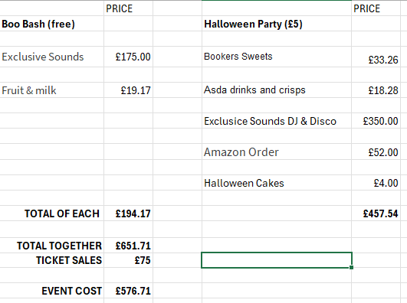
TOTAL EVENT COSTS:

Bauble Decorating – 29th November 2025 – This is all planned to go ahead with an order being made to get the stock in ready for Christmas market.

2026
Defibrillator Workshop – April 9th
The Event Supervisor has booked in a Defib Workshop for under 18s during the April Half term which this year seemed to have the best interest for educational events.
This will be hosted by Hopkins + and will be promoted online and to the schools in February 2026.

Battle of the Bands (BOTB)
Do you want this to run again in 2026 for a second year running?
Is there a set budget? Do you want to increase this?
Overview from the 2025 event:
BOTB 2025 costs us £500 including the cash prize.
We had three bands sign up with two playing on the day.
If this does go ahead, promotion for the event will be earlier to hopefully reach across to more people.

