ATTACHMENT 1
BROADSTAIRS & ST PETER’S TOWN COUNCIL
TERMS OF REFERENCE FOR

Environment COMMITTEE

Approved by Council on 26 April 2021- updated June 2025

MEMBERSHIP
- The Environment Committee shall consist of a minimum of five Councillors.
- The Council’s Volunteer Tree Warden in an advisory capacity when requested.
- Councillor members shall have full voting rights on the committee.
- Non-councillor members shall have no voting rights.

PROCEDURES
- At the first meeting of the Environment Committee after the Annual Meeting of the Town Council the Committee shall elect a Chairman and Vice Chairman for the forthcoming year from amongst the committee membership. The Chairman and Vice Chairman may be re-elected.
- The committee will submit minutes of their meetings to the next meeting of the Full Council Committee and seek approval for recommendations made.
- The annual budgeting process will allocate funds to the Environment Committee which will propose how they will be spent.
- The Clerk to the Council or an appropriate officer shall provide administrative support for the Committee.
- The quorum for the committee shall be three. Business cannot be transacted with fewer than three voting members present.

FREQUENCY OF MEETINGS
- The Committee will normally meet bi-monthly. The schedule will be established by the Clerk and the Chairman of the Committee and published along with all other committee meetings.

- Meetings will take place at Pierremont Hall or other suitable venue or via Zoom and will be open to the public.

COMMITTEE FUNCTIONS –

The committee shall undertake actions and priorities as identified in the Environmental Strategy adopted by Council on Monday 25 January 2021 (min 398)

ATTACHMENT 2

Broadstairs & St Peter's Town Council
ENVIRONMENTAL COMMITTEE
Minutes of the meeting held at 7pm on Monday 24th March 2025.
Cllrs Present: Chair Joanne Bright, Vice Chair Steve Roberts, Cllr Kevin Pressland.
Cllr Alan Munns, Cllr Mike Garner, Cllr Paul Moore
Officer: Civic and Support Officer: Abi Barton

60. CHAIRS WELCOME: OPENNESS AND TRANSPARENCY
To remind those present of the following:
The right to record, film or broadcast any meetings of the Council, committees and subcommittees is established following the Local Government Audit and Accountability Act 2014.

61. APOLOGIES FOR ABSENCE
Apologies with reason from Cllrs Kemp and Hobson were given and accepted.

62. DECLARATIONS OF INTEREST
None received.

63. MINUTES OF LAST MEETING

RESOLVED: That the minutes of the Council meeting held on 13th January 2025 can be approved and duly signed as a true record by the Chairman.

64. MATTERS ARISING FROM THESE MINUTES NOT COVERED ELSEWHERE IN THE AGENDA
It was noted by the Civic & Support Officer that since the last meeting, minute 56. TREE PLANTING PROJECT WITH THANET DISTRICT COUNCIL.
TDC coms team have used Town council owned pictures to promote the TDC Tree planting project that the Town council donated £10,000 to, without any mention of the Town Council’s help with funding this project.
RESOLVED:
All members expressed their disappointment.
Civic & Support officer is to complain to the department head of TDC to rectify this issue.

65. QUESTIONS AND/OR OBSERVATIONS FROM THE ELECTORATE OF BROADSTAIRS AND ST PETER’S
None received.
66. LAND AT FAIRFIELD
Members received an update regarding the meeting with Contact Box Green NJL to quote for meadowing the land.
RESOLVED:
Members agreed with Officers recommendation with knowledge supplied by contactor and Cllr Pressland that due to the high levels of ground elder, Alexander and other fast spreading plant varieties such as ivy and limited options/ budget available for removal, this land is not appropriate for a wildflower meadow due to its cost implications.

67. LAND AT FOSTERS AVENUE
Members received an update that the Tree planning application for this land had been rejected by KCC due to number of cables above the land and below.
KCC did however approve the cultivation licence.
On approval of the cultivation licence, it was noted that the C&S Officer and Operations Officer visited the site for a H&S inspection and to understand why the trees had been rejected when there had previously been trees planted in the location and removed.
It was noted that it appeared BT had done further works to the area, creating new trenches on the pathways and adding more phone lines to the pole above, creating a safety issue.

On inspection of the grass areas that had been granted the cultivation licence to meadow, it was noted that where the grass had stopped being maintained by KCC. Ground elder and several weed varieties, that were not present during the Town Council’s initial site visit during the summer, had taken over the land. As noted by our contactor during a meeting at Fairfield, ground elder would prove difficult to meadow over, therefore this plot of land would only be suitable for grass which requires continuous maintenance.

RESOLVED:
Prior to the meeting the C & S Officer discussed the changes on the land with the Town Clerk and Chair of the Committee. Due to time sensitivity that the cultivation of the plot of land was now the responsibility of the Town Council. It was decided that this would not be good use of Town Council budget and the cultivation licence be rejected and structures licence not applied for as this is no longer a viable project.

A new site was to be investigated. This did not affect the agreed contactor’s planting contract, as the section was referred to as “new meadow land” in agreed quote.
Members agreed to note.

68. NEW MEADOW PROJECT – CULMERS
Members received a planting proposal sent to landlords of Culmers Amenity Land, CT10 Charities that includes a planting fruit or nut trees, a wildflower meadow and planting native bulbs as a community project in the autumn months.
CT10 Charities have confirmed they would be happy with the creation of a meadow and bulbs to be planted in the woodland area. Tree planting is to be discussed at their next meeting in April.
RESOLVED:
Members agreed that the proposal is to be approved and further funding for the bulb planting project is to be allocated. Purchasing will be at the officer’s discretion.
It was agreed that the bulb planting day should be a collaboration with the Youth forum, local schools and other volunteers.
C&S officer is to confirm with CT10 Charities and the contractor, the start of this project and to purchase bulbs for this land and a community project is to be organised to plant in the autumn months.

69. BROADSTAIRS IN BLOOM
The C & S officer has been looking at refreshing the current In Bloom Campaign with new projects and rethinking old projects for better community engagement, to come in line with the Town Council’s current action plan and motivations.

- Business baskets to family planting day:
Whilst last year was our highest number of hanging basket orders for businesses (selling all 120 baskets), it was also the highest number of unpaid, broken and stolen baskets the Town Council has witnessed.
Members received a proposal for the new hanging basket project, creating a fun, new family friendly activity, which promotes gardening and uses our space at Pierremont Hall. This would also guarantee a return on the budget spent on baskets.

- Rubbish to Roots:
Members received a proposal for Broadstairs & St. Peter’s Town Council to team up with Broadstairs Town Team to encourage local residents to use items they would usually see as rubbish and turn them into planting vessels to create a metre of beauty in their homes and gardens. With key message that anything can be a planter. The proposal included that the Town Council fund this pilot project supplying seeds, climbing canes and compost if necessary. The Town Team would lend a helping hand to promote this project, supplying some locally grown seeds and using their seed drives to hand out the seed packs.
The Town Council will create a social media campaign showing their own ‘Roots to Rubbish’ and encourage members of the public to get involved with their own items.

- Gardening Grants:
Members received a new poster for the current in bloom grants project.
Members were asked to consider continuing this project to give grants to schools, care homes and organisations.

RESOLVED:
- That the family planning day is approved by all members as it is more economical and supports healthy eating and education.
Two ticket prices are to be available to members of the public, one that includes a free mocktail making session and one without.
Members agreed that this project is to be advertised to local women’s groups/ men’s groups, brides and hens of Pierremont Hall, local care homes, schools and youth groups.
It was noted that the Town Council could offer a basket delivery service for those who attend with accessibility issues.

- All members agreed that the proposal for the ‘Roots to rubbish’ Project be approved.
£500 from the in-bloom grants budget can be used to purchase
necessary items.

- To promote this project to local schools in the first instance.

To continue this project alongside the in-bloom projects, continuing to promote to schools, care homes and organisations.
70. REFILL/ TAPS PROJECT.

- Refill project:
C&S Officer and Town Clerk had a meeting with TDC heads and managers of departments following a proposal for a new tap site sent by the C& S officer.

The meeting was positive, with discussions of multiple options for a new water tap site, including Balmoral Gardens, Pierremont Park, Broadstairs Promenade and Victoria Gardens.

It was agreed by all parties that Broadstairs and Sr. Peter’s Town Council could pay for the tap unit and install. However, the maintenance and water costs would be covered by TDC.

TDC are to investigate the disabled toilet next to the bandstand at Victoria Gardens as the install location. TDC operatives will be surveying this area to make sure this is a viable location; the unit would then be installed during TDC’s toilet renovation project to minimise cost.

TDC are to send the Town Council a quote for install ASAP.

- Refill project:
The first few stickers have been handed out to businesses. The C&S Officer will continue to push this campaign.

RECOMMENDATION
- It was agreed by all members that the remaining environmental initiatives budget of £4307 left is to be ringfenced and added to the budget heading of “environmental initiatives” in the 2025-26 budget for purchasing of the tap unit and install costs and signs.

- Members agreed to note.

71. HIP AND TRAFFIC INITIATIVES

- HIP:
The C&S Officer has chased KCC for updates relating to the HIP and Speed watch.
The following response has been received from KCC:

“Unfortunately, I don’t have an update for you as yet but these priorities are with P&A awaiting their assessments. Both Planning & Advice and Design & Delivery Teams work on Crash Remedial Measure schemes as a priority for some months of the year and this has been the case so far, but I hope that they will be back to working on parish schemes as soon as possible.”

- Speed watch:
The Deputy Town Clerk who is leading speed watch and the C &S Officer has chased Speed watch to identify roads that would be viable to start a campaign. No useful response has been received yet.

- Working with KCC and Schools:
As reported at the previous council meeting in January, The C&S Officer and Schools Liaison councillor, Cllr Bright attended a virtual meeting where there were many positive discussions of working collaboratively with KCC. Since this meeting the C &S Officer has invited the safter roads team to attend the community festival on 24th May.

Cllr Bright has attended the youth forum to discuss working with school heads.
It was noted during the meeting with KCC that the C&S officer/ Cllr Bright would contact school leadership teams to attend an event/workshop at Pierremont Hall to educate schools to help them fill out their own action plans and discuss road safety measures near their schools. This is still to be organised and will be pursued in the coming months. As discussed at minute 53.TRAFFIC COMMUNITY OUTREACH on 13th January 2025.

RESOLVED:
- The C& S Officer will continue to pursue KCC and Speed watch.
- C&S officer is to organise a meeting with Kent Speed watch and KCC speed up process and identify roads. Once the roads have been identified, the C& S Officer is to promote a volunteer drive.
The C&S Officer is to research quotes from speed watch equipment to purchase and to lease.
- Members agreed to note.

72. PROPOSED FORWARD AGENDA ITEMS & DATE OF NEXT MEETING
Date of next meeting TBC on approval of calendar of meetings.
Meeting Closed at 20:28


Attachment 3
Quote for reseeding Osborne Road due to unknown member of public covering area in grass seed.
Scarify area, rake & remove arisings created by scarifier; overseed & roughly rake to bed seed in
Price £450.00 + VAT
Using seed mix below (Restore and Enrich)


Attachment 4 available as a separate document due to size.

ATTACHMENT 5
Community Speedwatch Equipment
All equipment can be purchased from the Speedwatch shop (details of equipment shown below). The difference between the two is the type of radar gun included.
We are waiting details from Ramsgate Town Council regarding the possibility of borrowing their equipment, and if so, at what cost.
At this time, we are also waiting to hear from Alan at Speedwatch regarding the roads which Abigail put forward. Alan will confirm whether these roads can be put forward for Speedwatch.
Once the roads have been confirmed, volunteers will be required. The volunteers will need to undertake the training on the Speedwatch website, and then it will be for the volunteers to coordinate their own Speedwatch days.

From Community Speedwatch Shop
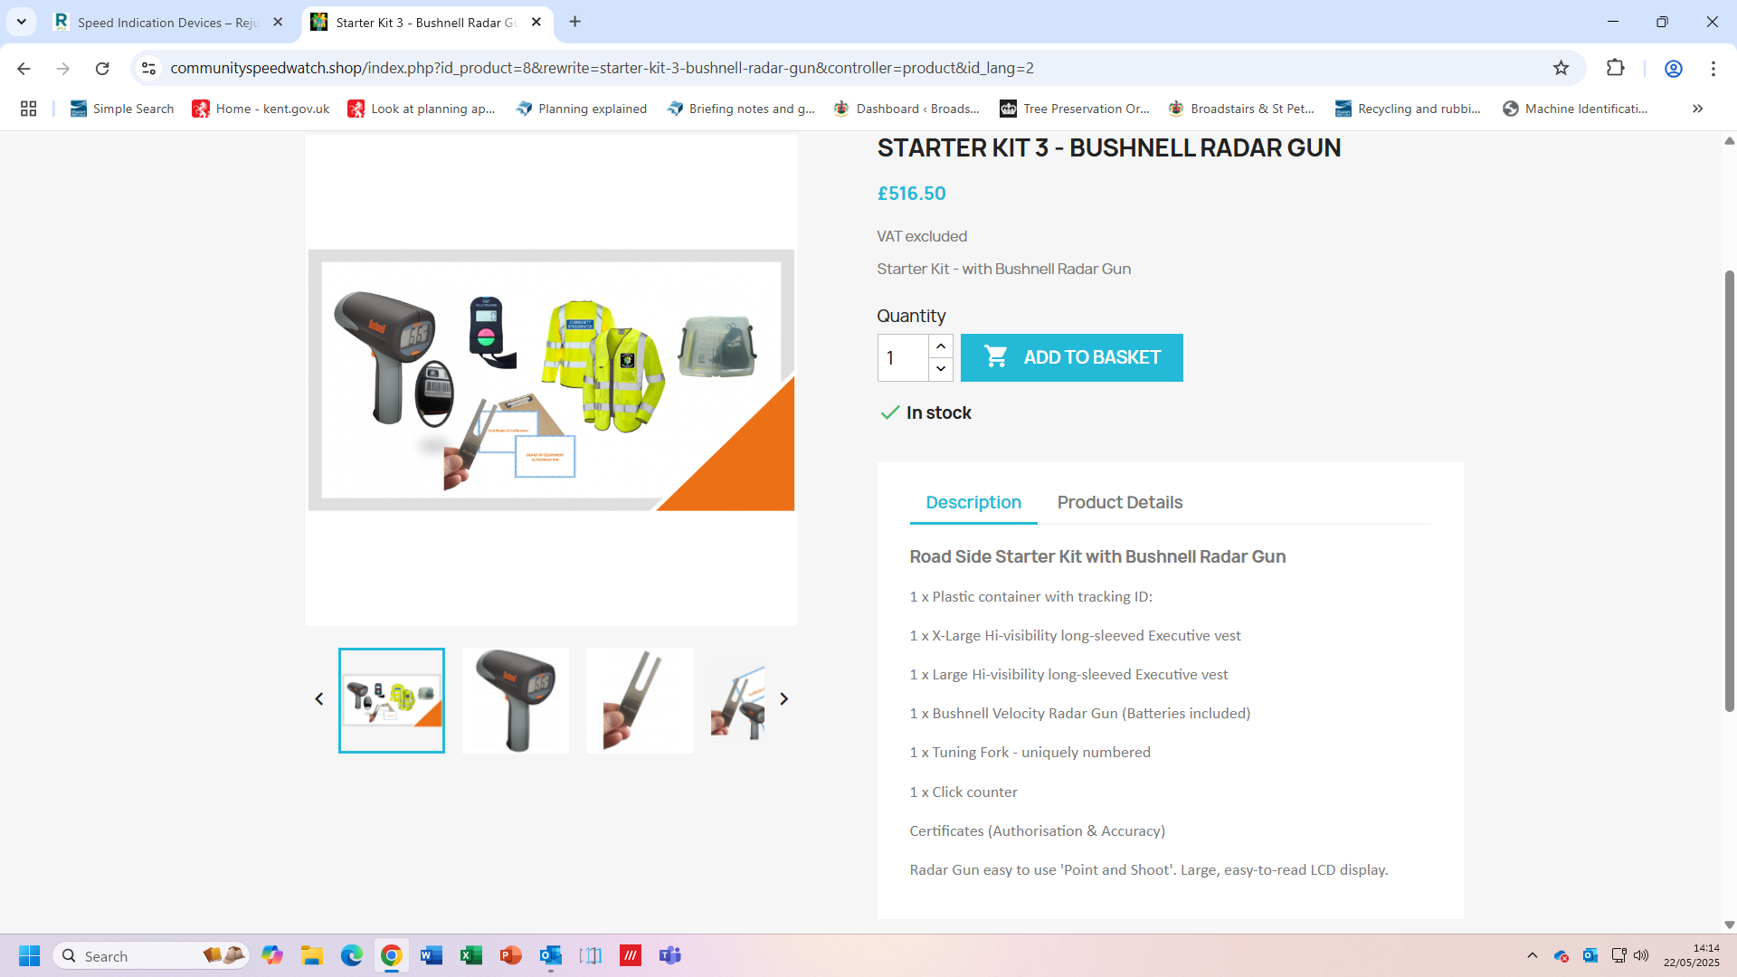


- Directional target acquisition (towards/away & both – direction sensing)
- Intuitive “over & under” speed display, fast/strong displayed simultaneously
- Large 2.8” white on black LCD Display with auto-dimmable capabilities
- Faster target or Strongest Signal mode
- Display compatible with Polarised sunglasses
- Lock target speed for easier traffic violation handling
- Customisable automatic power off – longer battery life!
- 7 days of usage in between charges -estimated for regular law enforcement usage
- Charge indicator- low battery alert to secure your radar is always operational
- USB charging port
- Skid resistant enclosure

