
Recent activity in the woods…
Mockett’s Wood 23-05-25:
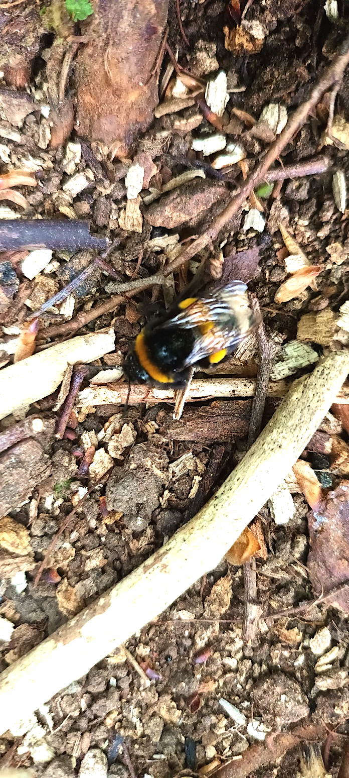
An exciting start to this week with the local RSPB team joining the Saturday volunteer session to start surveying Blue Tit nesting boxes in the woods. More on this when the survey is complete & data available…

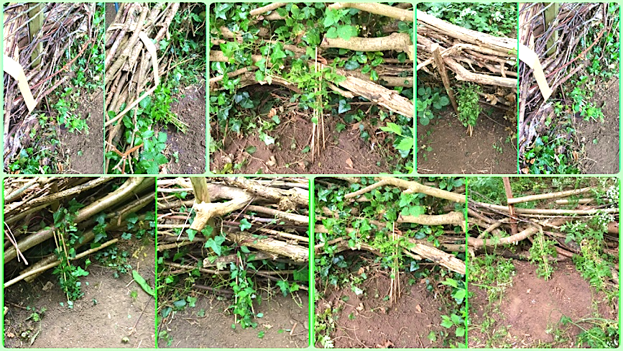
We also found an emerging nest of white tailed Bumble bees [Bombus lucorum] with 20+ young worker bees coming out of the nest accompanied by the queen. An amazing sight & sound + another entry to add to the growing species list for the woodland.

The session also focussed on watering the 12 new wild clematis & honeysuckle plants installed near some of the existing dead hedging, along with the usual litter picking, bin emptying & controlling the ever present Alexander plants [Smyrnium olusatrum].

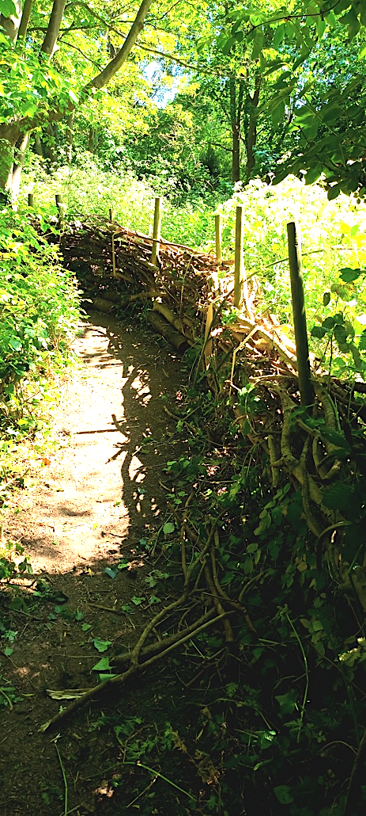
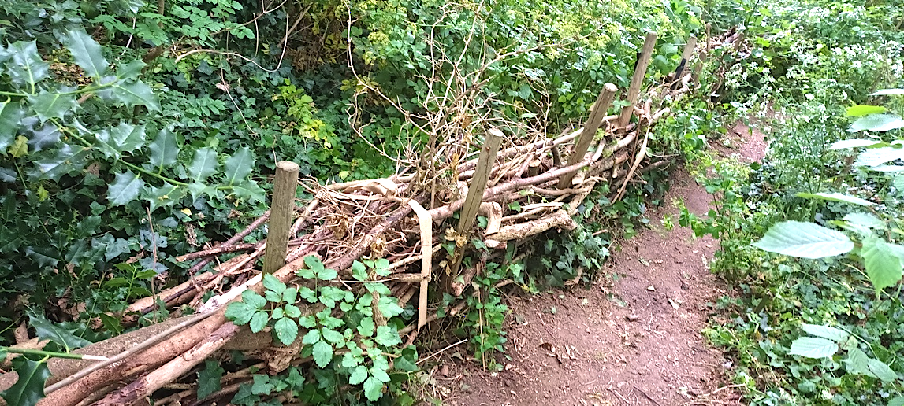
Dead hedging repairs & upgrades have continued & a new section of path was opened up + dead hedging installed to protect the bumblebee nest we discovered.

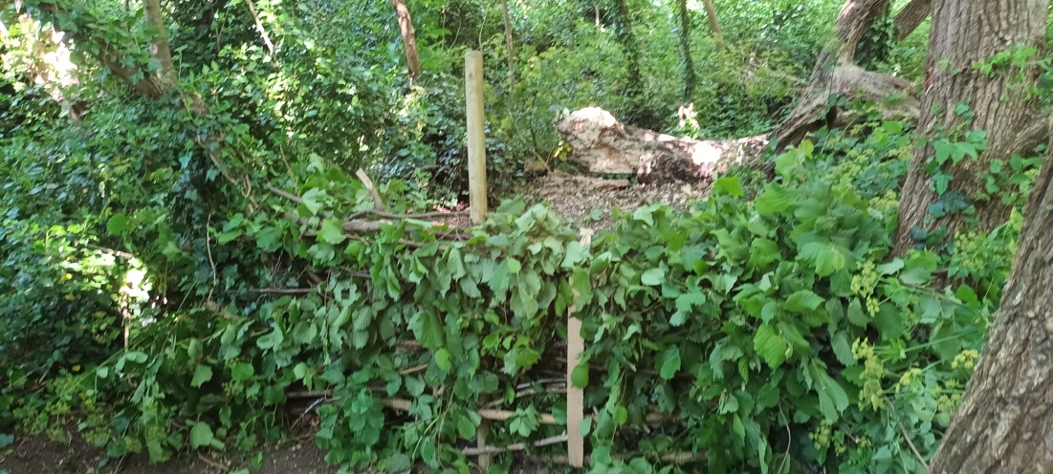
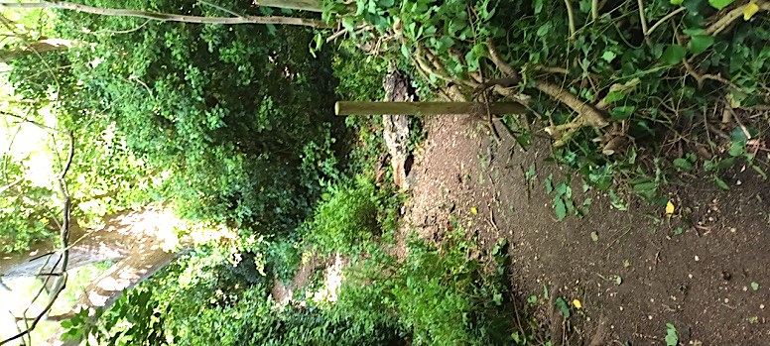
New dead hedging to block off some of the surplus paths has also started & re-wilding of the compacted paths will start soon.

There is also a section near the centre of the woods earmarked for recovery under 2 large trees. Around 14m of dead hedge might be needed to partition this off. A temporary jute cord barrier has been installed as a trial…
