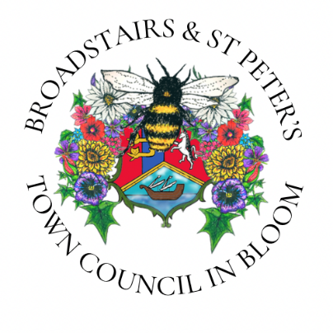
BROADSTAIRS & ST. PETER’S TOWN COUNCIL
BUSINESS HANGING BASKET HIRE 2022

Please return this form to:
The Town Clerk’s Office, Pierremont Hall, Broadstairs, CT10 1JX
Via Email: admin@broadstairs.gov.uk or call: Call 01843 868718
Orders close 12pm 13th May 2022

Once Broadstairs & St. Peter’s Town Council have received this order form, you will be contacted with order confirmation and payment details.
Please note that only 200 baskets are available to businesses at the price of £8.50, this will be a first come first served basis.
Date of form completion:

Name:

Name of business:

Delivery address/business address:

Daytime contact number:

Email address:

Number of baskets required at the price of £8.50 per basket:
Please note that your contact number and delivery address will be shared with our contractor for basket delivery purposes.
Basket Specifications:
Deluxe rattan baskets worth £20 for only £8.50 each
A variety of flowering plants in red, white, blue, purple and silver for the Jubilee. This is the same colour combination that is to be used across Thanet's planters and lamp column baskets.
These hanging baskets will be brown rattan, filled with good quality compost with slow-release fertilizer.
The price is including delivery and pick up at the end of the season. All you need is a basket bracket and to water when needed!
Only 200 baskets available for businesses, order fast to avoid disappointment!

