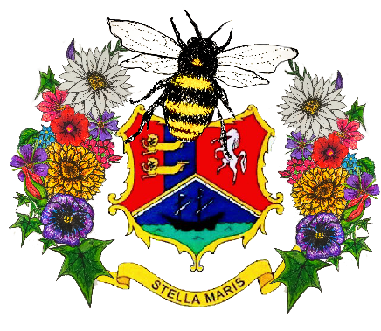
Broadstairs in Bloom Basket hire 2021
Name
Name of Business
Address of business that the baskets will be delivered to
Daytime contact number
Email address

Basket type | Number of baskets
Blue/Purple Mix
Total Colour Mix
Summer heat
(red, orange, yellow)
Total Number of baskets
Total price at £8.50 per basket

BACs Payments only
Email admin@broadstairs.gov.uk for payment details
Please return this form to admin@broadstairs.gov.uk by 24/05/21

