In January 2022, The Broadstairs Town Team entered all eight gardens they maintain in the town into the South & South East in Bloom category “It’s Your Neighbourhood”.
They were grouped into five entries:
Albion Street Car Park
The Broadway Banks and Station Area (Crampton, Library and Lavender Banks and Station Area.
Louisa Bay Access Road (including Queens Garden)
Ramsgate Road
Wrotham Crescent Community Garden
Our entries were all assessed on a hot sunny July day by none other than Peter Holman, the chair of South & South East in Bloom. The eagle-eyed Peter noticed every plant and gave a running commentary of hints and tips as he walked round each area. One of our volunteers described him as a “walking encyclopaedia of horticulture”.
After weeks of waiting, the Awards date was announced, only to be postponed as a mark of respect for our late Queen.
At last, on 23rd of September, a small group of our volunteers sat in the hall in Farnham eagerly awaiting our results. As tensions mounted, we held our breath. Our first entry received a “Thriving” Award then the category moved to “Outstanding”. We looked at each other and crossed our fingers. Our first “Outstanding” Award was announced, followed by another and another and when we accepted our fourth “Outstanding” Award we received a round of applause. The compare asked the audience to remain quiet as the remaining awards were announced, no need, as we all hit the phones texting our amazing success to trustees, fellow volunteers, sponsors and last, but certainly not least our supporters in the Town Council.
For those not living and breathing In Bloom, “Outstanding” is the highest award in the category.
So how did we do:
RHS IT’S YOUR NEIGHBOURHOOD 2022 RESULTS SCORES
Albion St Car Park LEVEL 5 A 35 B 27 C 24
TOTAL MARKS 86 OUTSTANDING
Broadway Banks & Station Area LEVEL 5 A 36 B 27 C 27
TOTAL MARKS 90 OUTSTANDING
Louisa Bay & Queens Gardens LEVEL 5 A 35 B 26 C 27
TOTAL MARKS 88 OUTSTANDING
Ramsgate Road LEVEL 4 A 32 B 24 C 21
TOTAL MARKS 77 THRIVING
Wrotham Crescent Community Gdn. LEVEL 5 A 33 B 26 C 27
TOTAL MARKS 86 OUTSTANDING
Understanding the Scores
A is for Community Participation 40% of the marks max score 40
B is for Environmental Responsibility 30% of the marks max score 30
C is for Gardening Achievement 30% of the marks max score 30
Score Band widths: Advancing 53 - 68; Thriving 69 - 85: Outstanding 86 -100
Although our 2022 entries were slightly different from 2021, all improved their overall scores.
Volunteers Sue Wainwright and Felicity Lewis accepting one of our Awards from
Mark Porter Chair of Britain in Bloom Federation
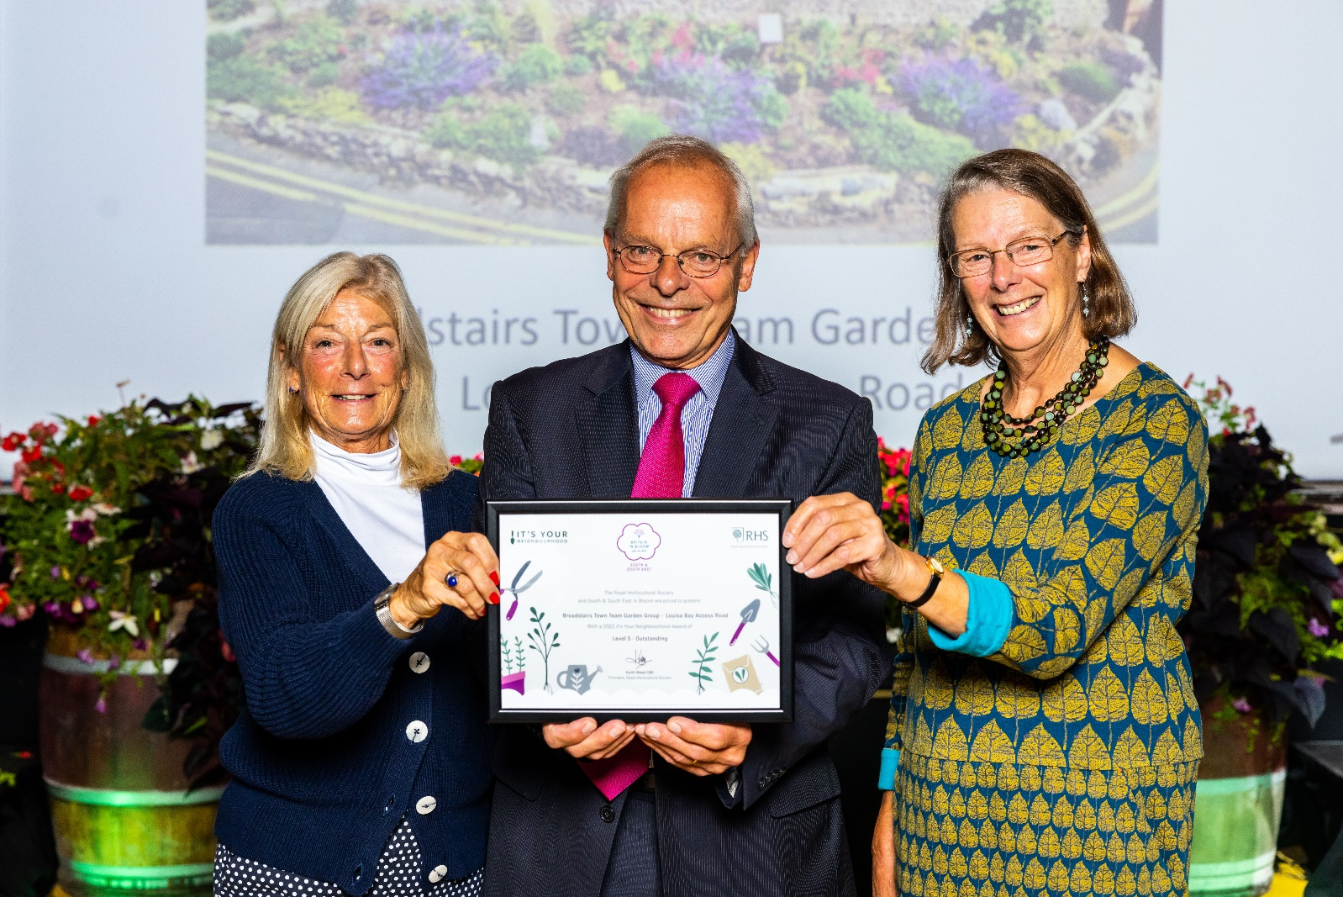
While the Town Team volunteers do a wonderful job of maintaining the gardens, It’s Your Neighbourhood is all about community and our collaborative efforts to make Broadstairs a better place to live and work.
Saturday 8 October was a day to down tools and celebrate our gardening success with our wonderful volunteers, enthusiastic supporters and generous sponsors, too many to mention.
Kirsty Holroyd, Town Clerk, Gareth Palmer, The Potting Shed, Councillors Ruth Bailey and Mike Garner and Alex Locardi, Fujifilm all received certificates of thanks from Kerry Millett, The Broadstairs Town Team Chair on the day.
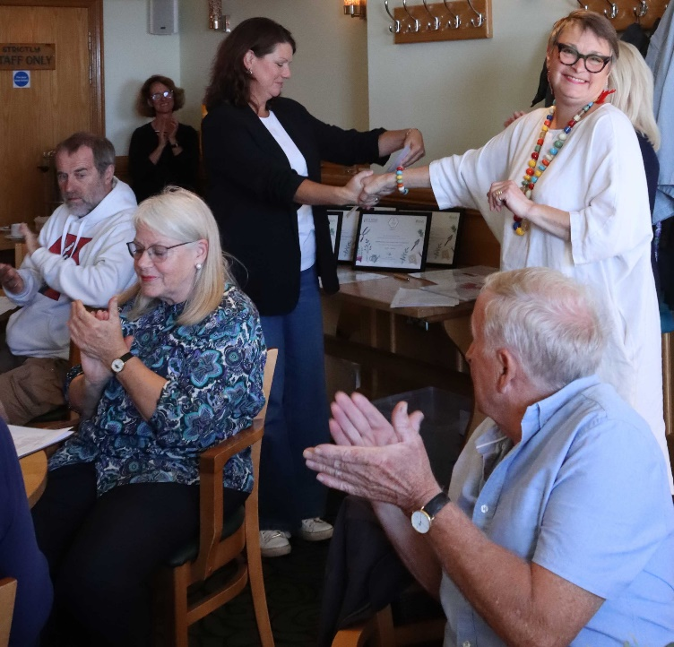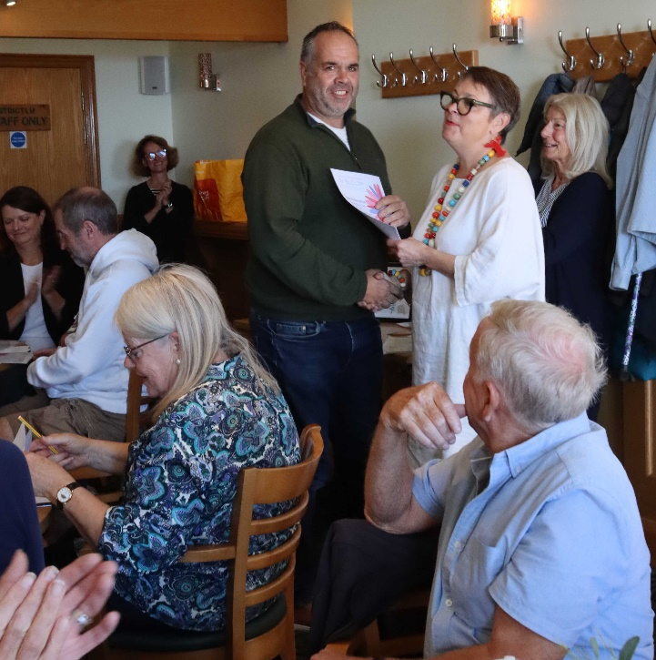
Jackie, Youngs Nurseries, Mike Bridges and Kerrie, The British Garden Centres were unable to join us on 8 October so we have been out and about to thank them and present their certificates.
